Detailed Design Document
Sponsor Name:
Document ID: Detailed Design Document_ MES_Interface
Blueprint Design Document ID: LIMS_Phase2_Blueprint Design_MES_Interface_CN_Final

Version No. | Authorized by | Approval date
1.00

Table of Contents
1 Table of Contents 2
1 Objective 3
2 Detailed Architecture 3
2.1 Just-In-Time (JIT) Sample Integration 3
2.1.1 Functionality Overview 3
2.1.2 Interface Configuration 5
2.1.3 Data Flow – JIT Sample 5
2.1.3.1 JIT Workflow 5
2.1.3.2 Background Task 5
2.1.3.3 JIT Sample End-to-End Workflow 6
2.1.4 .NET Tasks 7
2.1.4.1 Hen_SendJITResultToMESTask 7
2.2 IPQC Sample Integration 7
2.2.1 Functionality Overview 7
2.2.2 Interface Configuration 10
2.2.3 Data Flow – IPQC Sample 10
2.2.3.1 IPQC Workflow 10
2.2.3.2 Background Task 11
2.2.3.3 Usage Decision Logic 12
2.2.3.4 IPQC End-to-End Workflow 23
2.2.4 .NET Tasks 23
2.2.4.1 Hen_SampleAuthorizeTask 23
2.2.4.2 Hen_UsageDecisionTask 23
2.2.4.3 Hen_SendIPQCResultToMESTask 23
2.2.5 Configuration Specification 24
2.2.5.1 Structure Table Updates 24
2.2.5.2 Phrase 25
3 Change Log 25

Objective
The purpose of this document is to describe the technical design for the integration between QCLAD (SampleManager) and MES (Manufacturing Execution System), focusing on Just-In-Time (JIT) sample integration and In-Process Quality Control (IPQC) sample integration.
The intended audience for this document is the development team, and anyone else who will be installing, configuring, and supporting the application.

Detailed Architecture

Just-In-Time (JIT) Sample Integration

Functionality Overview
1. Business Scenario
- In the Just-In-Time (JIT) quality process:
  - Samples are manually created in QCLAD before the corresponding inspection lot exists in SAP.
  - After testing and authorization in QCLAD, quality results must be sent to MES.
  - Once SAP generates the inspection batch, QCLAD matches it to the pre-existing sample using internal logic.

2. JIT Sample Info Receiving (QCLAD → MES)
Integration Flow
- Authentication Setup:
  - Vegam will provide:
    - API path
    - Client ID
    - Client Secret
  - QCLAD will use these credentials to obtain a Bearer Token via Vegam’s OAuth API (https://sfs-ap-test.henkelgroup.net/VegamOauthServer/GetAccessToken).
- API Exposure by Vegam:
  - Vegam will expose an API endpoint ( https://sfs-ap-test.henkelgroup.net/VegamOauthServer/api/data/UpdateSampleQualityInfo) for receiving JIT sample QC data from QCLAD.
- Data Transmission:
  - QCLAD will send sample QC data in JSON format to the Vegam API.
  - The request will be authenticated using the Bearer Token.
3. Data Exchange
Request Payload (QCLAD → MES)
Response Payload (MES → QCLAD)

4. Error Handling Need to handle errors in Sample Manager
ReturnCode | Description | Action By QCLAD
0001 | Success | No Action
0002 | API Authentication Error | Correct Authentication and Resend
0003 | Invalid Sample Number | Correct sample number and Resend
0004 | Invalid date time format | Correct the data and Resend
0005 | Invalid JSON | MES Will take care further process

5. Field Mapping for Request Payload ( https://sfs-ap-test.henkelgroup.net/VegamOauthServer/api/data/UpdateSampleQualityInfo) Need to map the Field
No. | MES Field | Description | QCLAD Field Mapping
 | sampleType | sample Type | sample.HenInspectionCategory
 | sampleLabelNumber | Unique ID for the sample | sample.HenMesId
 | processOrder | SAP Process Order | Sample.HenProcessOrder
 | batchNumber | SAP Batch Number | sample.BatchName
 | materialNumber | SAP Material Code | sample.Substance.Identity
 | materialDescription | Description of material | sample.Substance.Name
 | plantCode | SAP Plant | sample.HenPlant
 | activityNumber | SAP phase in the routing | sample.HenPhraseNumber
 | sampleApprovalRejectedTime | Date and time sample was approved/rejected | sample.DateAuthorised
 | operatorName | Operator who approved sample | sample.Authoriser
 | QCSampleResult | Approved or Rejected | sample.Status and sample.OnSpec
 | isQCAdjustment | is QC Adjustment | NA
 | adjustMaterials | The material information that needs to be adjusted can be zero or more. | NA
 | consesssionRelease | consesssion Release | NA
 | resampleRequired | If the phase required re sample | NA
 | remark | Comments | NA
 | QCLabItemResultList |  | NA

Interface Configuration
We need to add interface configuration for error handling, capturing logs, and receiving MES response payloads.
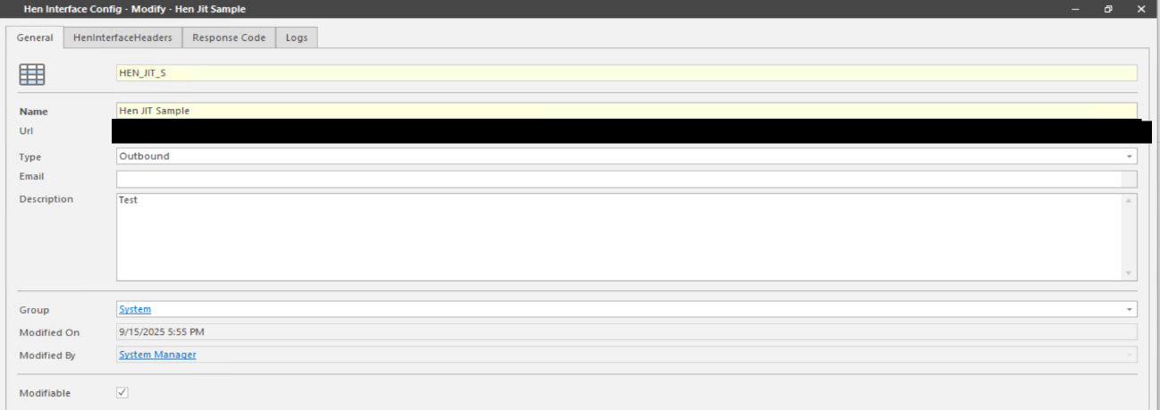

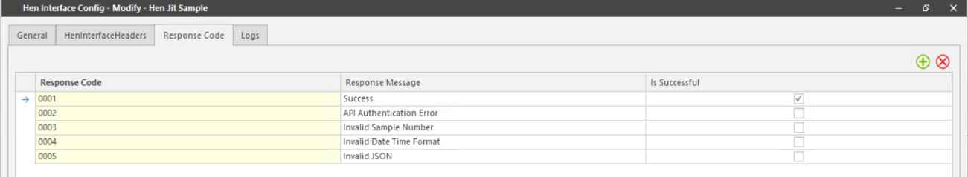

Data Flow – JIT Sample

JIT Workflow
- Sample will be created using JIT workflow
- Sample authorized event will be triggered once result are authorized and Hen_MES_To_Be_Sent sets to “Yes”.

Background Task
- A background job will run every 5 minutes.

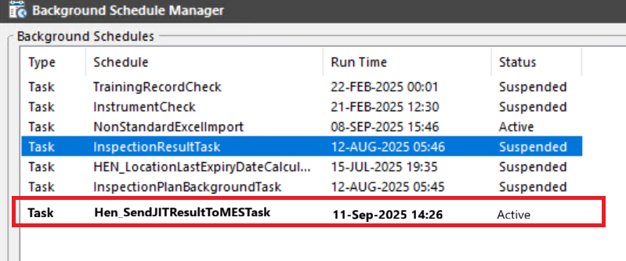

- It retrieves samples where:
- Hen_MES_To_Be_Sent = true
- Hen_MES_Has_Sent = false

- For Each Sample
- QCLAD sends QC data to MES via API.
- On Successful Transmission
  - Hen_MES_Has_Sent is set to Yes.

{
"sampleType": "RECEIVING_SAMPLE",
"sampleLabelNumber": "0000216316",
"processOrder": null,
"batchNumber": "A1233",
"materialNumber": "383743",
"materialDescription": "Adeka Hardener EH 4070 S",
"plantCode": "0799",
"activityNumber": null,
"sampleApprovalRejectedTime": "YYYY-MM-DDTHH:mm:ssZ",
"operatorName": "4454", // To be discuused
"QCSampleResult": "Pass", //Pass or Reject
"isQCAdjustment": false,
"adjustMaterials": [],
"consesssionRelease": false,
"resampleRequired": false,
"remark": "",
"QCLabItemResultList ":[]
}

JIT Sample End-to-End Workflow
QCLAD MES
- Calling Vegam's API using OAuth2 client credentials (Client_Id, Client_Secret)
- Sending QC sample results in JSON format via POST to Vegam
- Exposing an API in QCLAD for MES to send JIT sample info
QCLAD → MES Integration Workflow (JIT)
Step-by-Step Flow:
1. Sample Created Manually
→ In QCLAD
2. Sample Authorization Done
→ Sample gets approved
3. Get OAuth Token from Vegam
→ Use client ID & secret (shared by Vegam)
→ Call Vegam OAuth API to get Bearer Token
4. Send Sample Result to MES
→ Use Vegam’s API (with Bearer Token)
→ Send sample result JSON (Pass/Reject, QC details)
→ Response will be recorded in the log table
→ Log viewer to review the status of the data transfer

.NET Tasks

Hen_SendJITResultToMESTask

Hen_GetOAuthToken()
- Retrieves access token Calling Vegam's API using OAuth2 client credentials (Client_Id, Client_Secret)

Hen_SendSampleResult()
- Sending QC sample results in JSON format via POST to Vegam API

IPQC Sample Integration

Functionality Overview
1. Business Scenario
- Samples are manually created in QCLAD
- After IPQC (In-Process Quality Control) testing, QCLAD sends test results to MES.
- The results can include:
  - Accepted samples
  - Rejected samples with:
    - Adjustment requirements (“done by QC” and “not done by QC”)
    - Resample requests
    - Off-spec rejection
  - Accepted with Concession

2. Interface Requirements
Data Transmission from QCLAD to MES
- Upon completion of IPQC testing, QCLAD pushes the following data to MES:
  - Usage decision
  - MIC results
  - MES Sample ID
  - Adjustment material and quantity (if applicable)

Usage Decision Logic
- All MICs Passed: Send "Accept" code to MES.
- One or More MICs Failed: Based on QC selection, QCLAD sends one of the following:
a. Rejected with Adjustment
- Includes a flag: QC Adjustment or Manufacturing Adjustment
- If QC Adjustment:
  - Send:
    - Adjustment material
    - Adjustment quantity and UOM
    - Storage location
    - Free-text comments
  - MES creates a new adjustment phase.
  - If no stock is available, MES waits until stock arrives.
- If Manufacturing Adjustment:
  - MES must obtain adjustment details from manufacturing.
b. Rejected with Resample
- QCLAD allows QC to write instruction notes.
- MES sends a new sample without adjustment.
- QCLAD:
  - Shows popup to user for resample.
  - Creates resample for a virtual sample ID.
  - Waits for MES label.
c. Rejected as Off-spec
- MES:
  - Discontinues the process.
  - If it’s the last phase, does not proceed to packaging.
d. Accepted with Concession
- MES:
  - Continues to the next phase.
  - If it’s the last phase, proceeds to packaging.

3. IPQC Sample Info Receiving (QCLAD → MES)
Authentication
- Vegam provides:
  - API path
  - Client ID and Client Secret
- QCLAD:
  - Uses these credentials to obtain a Bearer Token via Vegam’s OAuth API (https://sfs-ap-test.henkelgroup.net/VegamOauthServer/GetAccessToken).
Sends QC data in JSON format using this token.
API endpoint
- Vegam/DCS exposes an API endpoint for receiving IPQC data ( https://sfs-ap-test.henkelgroup.net/VegamOauthServer/api/data/UpdateSampleQualityInfo).
- QCLAD sends data to this API after QC is completed.

4. Data Exchange
Request Payload (QCLAD → MES)
Response Payload (MES → QCLAD)
5. Error Handling Need to handle errors in QCLAD
ReturnCode | Description | Action By QCLAD
0001 | Success | No Action
0002 | API Authentication Error | Correct Authentication and Resend
0003 | Invalid Sample Number | Correct sample number and Resend
0004 | Invalid date time format | Correct the data and Resend
0005 | Invalid JSON | MES Will take care further process

6. Field Mapping for Request Payload ( https://sfs-ap-test.henkelgroup.net/VegamOauthServer/api/data/UpdateSampleQualityInfo) Need to map the Field
No. | MES Field | Description | QCLAD Field Mapping
 | sampleType | sample Type | sample.HenInspectionCategory
 | sampleLabelNumber | Unique ID for the sample | sample.HenMesId
 | processOrder | SAP Process Order | Sample.HenProcessOrder
 | batchNumber | SAP Batch Number | sample.BatchName
 | materialNumber | SAP Material Code | sample.Substance.Identity
 | materialDescription | Description of material | sample.Substance.Name
 | plantCode | SAP Plant | sample.HenPlant
 | activityNumber | SAP phase in the routing | sample.HenPhraseNumber
 | sampleApprovalRejectedTime | Date and time sample was approved/rejected | sample.DateAuthorised
 | operatorName | Operator who approved sample | sample.Authoriser
 | QCSampleResult | Approved or Rejected | sample.Status and sample.OnSpec
 | isQCAdjustment | is QC Adjustment | NA
 | adjustMaterials | The material information that needs to be adjusted can be zero or more. | NA
 | materialNumber | Material used for any adjustment during sampling | NA
 | batchNumber | bacth number of adjustment material | NA
 | quantity | Amount of material sampled or adjusted | NA
 | uom | unit | NA
 | storageLocation | storage Location | NA
 | consesssionRelease | consesssion Release | NA
 | resampleRequired | If the phase required re sample | NA
 | remark | Comments | NA
 | QCLabItemResultList |  | NA
 | InspectionLot | Lot number for IPQC | Hen_inspectionlot
 | inspectionCharNumber | Order no | test.hen_orderno
 | masterInspectionCharacteristics | MIC_code | test.hen_mic_code
 | inspectionCharacteristicsText | short_text | test.hen_short_text
 | inspectionMethod | Test Method | Test.TestMethod
 | inspectionMethodText | Test Method Name | Test.analysis.name
 | lowerSpecLimit | lower Spec Limit | MLP_VALUES.MIN_LIMIT
 | upperSpecLimit | upper Spec Limit | MLP_VALUES.MAX_LIMIT
 | decimalPlace | PLACES | result.places
 | measureUnit | unit | result.Units
 | resultRecordType | result Type | result.resultType
 | InspectionResult | result value | result_raw_result
 | codeText | OnSpec | result.hen_on_spec

Interface Configuration
We need to add interface configuration for error handling, capturing logs, and receiving MES response payloads.
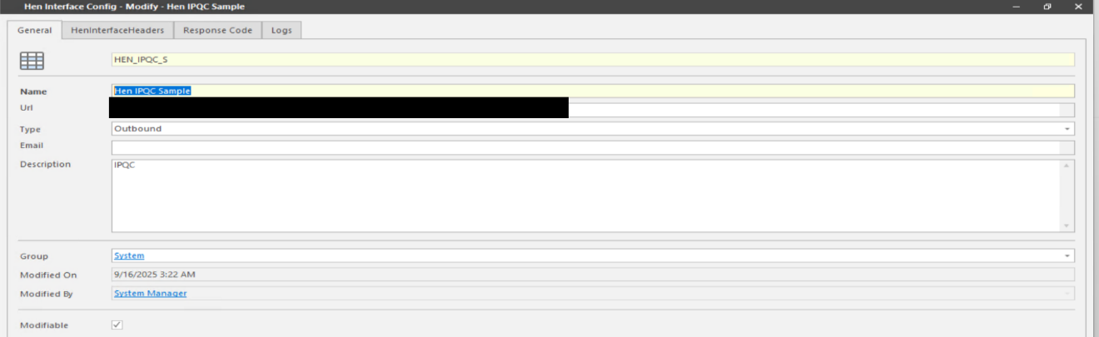

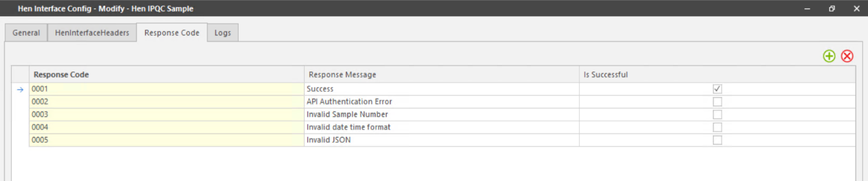

Data Flow – IPQC Sample

IPQC Workflow
- Samples will be created using IPQC workflow
- Sample authorized event will be triggered once result are authorized and call Hen_SampleAuthorizeTask to filed Hen_MES_To_Be_Sent sets to “Yes” and Usage Done as 'No'.
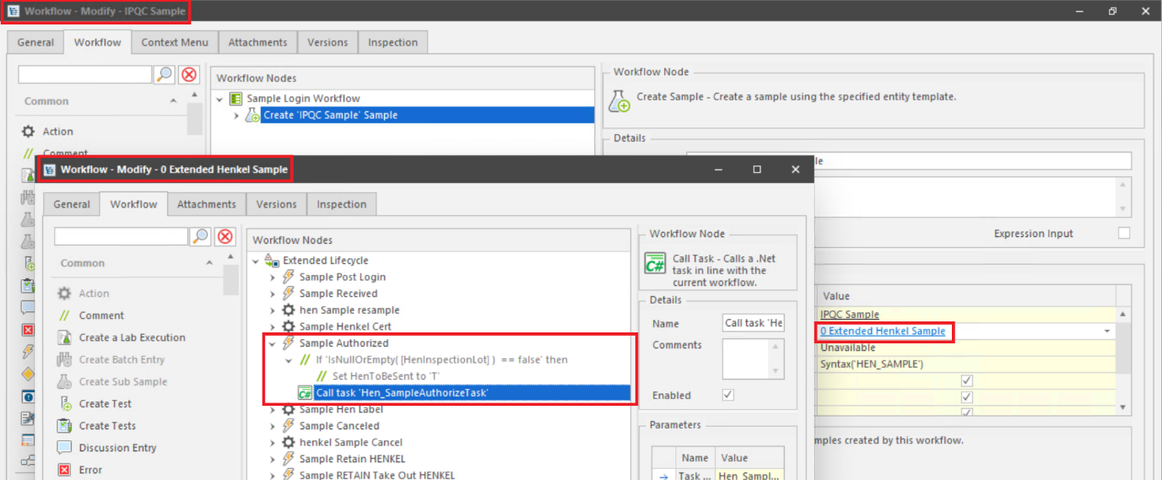

Background Task
- A background job will run every 5 minutes.
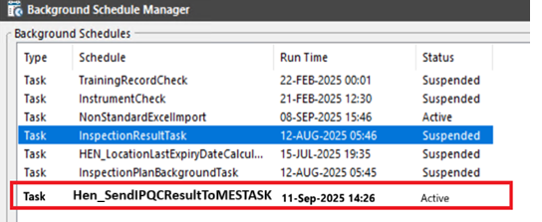
- It retrieves samples where:
- Hen_MES_To_Be_Sent = true
- Hen_MES_Has_Sent = false

- For each sample where usage done is equal to 'Yes'
- QCLAD sends data to MES via API.
- On Successful Transmission
  - Hen_MES_Has_Sent is set to Yes.

- Highlighting IPQC Samples Without Usage Decision
1. User Navigation
- User navigates to:
Sample Management Cabinet → Authorized Sample Folder → IPQC Subfolder
2. System Iterates Through Samples
- For each sample in the IPQC Subfolder:
  - Check if the sample type is IPQC.
3. Condition Check
- For each IPQC sample:
  - IF Usage Done = 'No'
→ Highlight the sample row in pink
  - ELSE
→ Display sample normally (no highlight)
4. Visual Feedback
- Highlighted samples (pink) act as a visual reminder to the user that:
  - The sample is authorized
  - But the usage decision is still pending
Condition | Highlight Colour | Action Required
Usage Done = No | Pink | User must complete usage decision
Usage Done = Yes | No highlight | No action needed

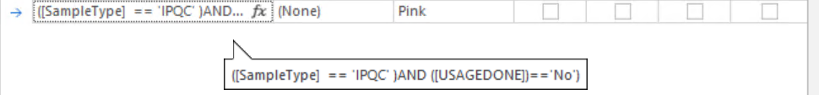

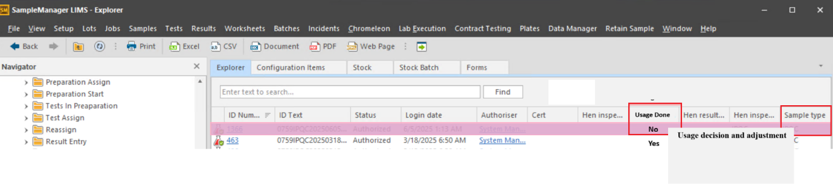

Usage Decision Logic
We need to create one RMB to perform “Usage decision and adjustment” as shown in above screenshot and will show up when the sample type is ‘IPQC’ and Usage done filed is ‘No’.
When users click on RMB “Usage decision and adjustment” master menu, it will pop-up default windows as below –
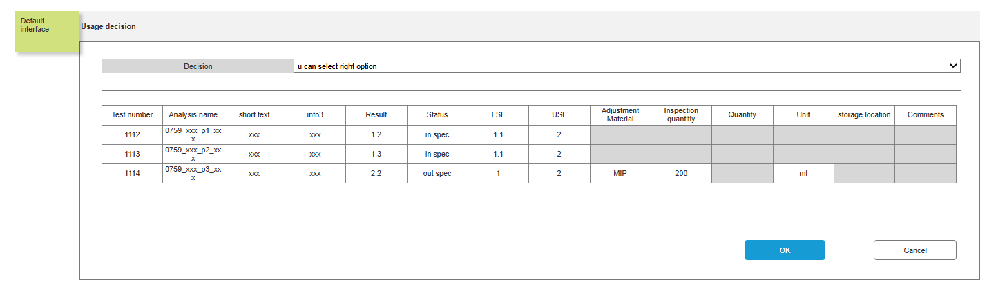

- For each sample where usage done is equal to 'No'
If all MICs are passed
  - Send decision "Accept" without adjustment information
  - When users select a usage decision and enter all mandatory information, then click the “OK” button, a confirmation popup window will appear.
  - If users click “Cancel” in the popup window, the Usage Decision window will be closed, and no information will be saved.
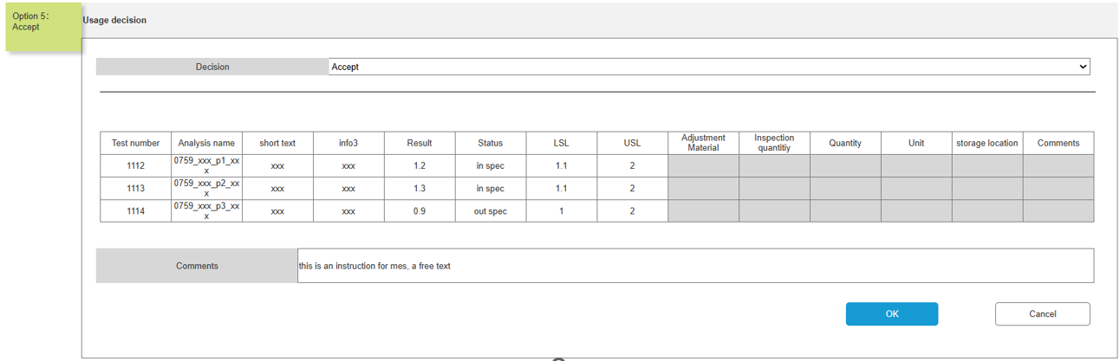
After entering the usage details a pop will be displayed to get confirmation whether to send it to MES or not.
  - If users click “YES” button, the following changes will occur:
    - The “Usage Done” field will be set to YES.
    - The “Hen_to_be_sent” flag will be set to TRUE.
    - The pink highlight will disappear.
  - If users click “No” button, no changes will be made:
    - The fields will remain unchanged.
    - The pink highlight will stay visible.
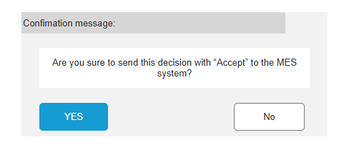
1. Accept
{
"SampleType": "IPQC",
"SampleLabelNumber": "371584",
"ProcessOrder": "001004172754",
"BatchNumber": "0007447212",
"MaterialNumber": "1392015",
"MaterialDescription": "Liquid Detergent Lavender",
"PlantCode": "0799",
"ActivityNumber": "0023",
"AampleApprovalRejectedTime": "YYYY-MM-DD HH:mm:ss", //plant time zone
"OperatorName": "John Doe",
"QCSampleResult": "pass", //Pass or Reject
"IsQCAdjustment": false, [True/False]
"IsFinalRejection": false, [True/False]
"AdjustMaterials": [
{
}
],
"ConsesssionRelease": false, //true or false
"ResampleRequired": false, //true or false
"Remark": "",// commet based on sample level
"QCLabItemResultList":[{
"InspectionLot":"1234567890",
“InspectionCharNumber":"0020",
"MasterInspectionCharacteristics":"00000069",
"InspectionCharacteristicsText":"TENSILE LAP-SHEAR STRENGTH",
"InspectionMethod":"00595101",
"InspectionMethodText":"Shear Strength-Block Specimens",
"LowerSpecLimit":254.5,
"UpperSpecLimit":290.6,
"DecimalPlace":1,
"MeasureUnit":"N/mm2",
"ResultRecordType":"N", //can be N-Numeric or O-Options
"Result":"275.7", //if result is type is N then decimal result as string else pass/fail
"Comments":""
}
]
}

If one or more MICs are failed
  - Option1A: user select “reject with adjustment” without clicking “done by qc” as below: Send decision "Reject with adjustment" with adjustment information
  - When users select a usage decision and enter all mandatory information, then click the “OK” button, a confirmation popup window will appear.
  - If users click “Cancel” in the popup window, the Usage Decision window will be closed, and no information will be saved.
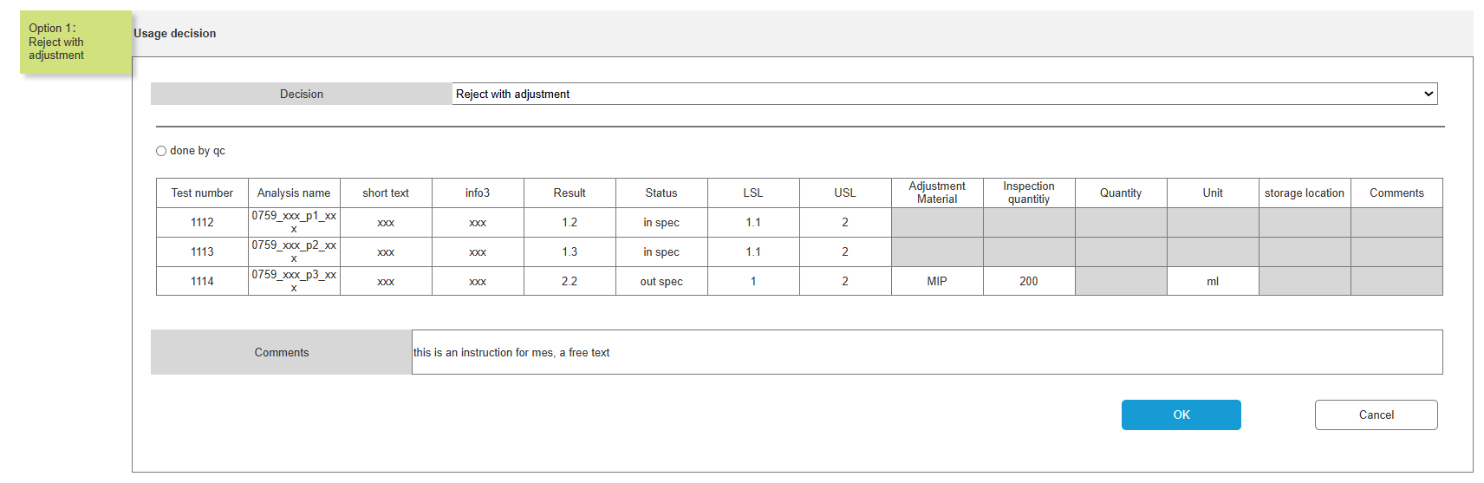
After entering the usage details a pop will be displayed to get confirmation whether to send it to MES or not.
  - If users click “YES” button, the following changes will occur:
    - The “Usage Done” field will be set to YES.
    - The “Hen_to_be_sent” flag will be set to TRUE.
    - The pink highlight will disappear.
  - If users click “No” button, no changes will be made:
    - The fields will remain unchanged.
    - The pink highlight will stay visible.
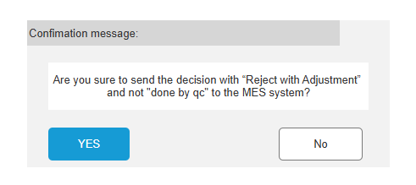
2. Reject with adjustment not “done by qc”

{
"SampleType": "IPQC",
"SampleLabelNumber": "371584",
"ProcessOrder": "001004172754",
"BatchNumber": "0007447212",
"MaterialNumber": "1392015",
"MaterialDescription": "Liquid Detergent Lavender",
"PlantCode": "0799",
"ActivityNumber": "0023",
"AampleApprovalRejectedTime": "YYYY-MM-DD HH:mm:ss", //plant time zone
"OperatorName": "John Doe",
"QCSampleResult": "reject", //Pass or Reject
"IsQCAdjustment": false, [True/False]
"IsFinalRejection": false, [True/False]
"AdjustMaterials": [
{
}
],
"ConsesssionRelease": false, //true or false
"ResampleRequired": false, //true or false
"Remark": "",// commet based on sample level
"QCLabItemResultList":[{
"InspectionLot":"1234567890",
“InspectionCharNumber":"0020",
"MasterInspectionCharacteristics":"00000069",
"InspectionCharacteristicsText":"TENSILE LAP-SHEAR STRENGTH",
"InspectionMethod":"00595101",
"InspectionMethodText":"Shear Strength-Block Specimens",
"LowerSpecLimit":254.5,
"UpperSpecLimit":290.6,
"DecimalPlace":1,
"MeasureUnit":"N/mm2",
"ResultRecordType":"N", //can be N-Numeric or O-Options
"Result":"275.7", //if result is type is N then decimal result as string else pass/fail
"Comments":""
}
]
}

  - Option1B: user select “reject with adjustment” with clicking “done by qc” as below: Send decision "Reject with adjustment" with adjustment information.
  - When users select a usage decision and enter all mandatory information, then click the “OK” button, a confirmation popup window will appear.
  - If users click “Cancel” in the popup window, the Usage Decision window will be closed, and no information will be saved.
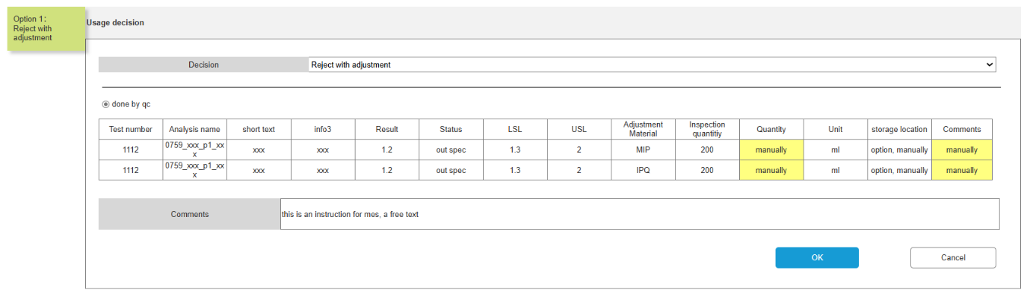
After entering the usage details a pop will be displayed to get confirmation whether to send it to MES or not.
  - If users click “YES” button, the following changes will occur:
    - The “Usage Done” field will be set to YES.
    - The “Hen_to_be_sent” flag will be set to TRUE.
    - The pink highlight will disappear.
  - If users click “No” button, no changes will be made:
    - The fields will remain unchanged.
    - The pink highlight will stay visible.
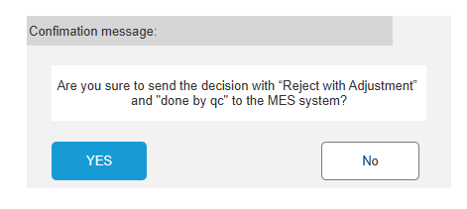
3. Reject with adjustment “done by qc”

{
"SampleType": "IPQC",
"SampleLabelNumber": "371584",
"ProcessOrder": "001004172754",
"BatchNumber": "0007447212",
"MaterialNumber": "1392015",
"MaterialDescription": "Liquid Detergent Lavender",
"PlantCode": "0799",
"ActivityNumber": "0023",
"AampleApprovalRejectedTime": "YYYY-MM-DD HH:mm:ss", //plant time zone
"OperatorName": "John Doe",
"QCSampleResult": "reject", //Pass or Reject
"IsQCAdjustment": ture, [True/False]
"IsFinalRejection": false, [True/False]
"AdjustMaterials": [
{
"MaterialNumber": "123456",
"BatchNumber": "BT01XZSH",
"Quantity": 10,
"UOM": "KG",
"StorageLocation" : "ST01"
}
],
"ConsesssionRelease": false, //true or false
"ResampleRequired": false, //true or false
"Remark": "",// commet based on sample level
"QCLabItemResultList":[{
"InspectionLot":"1234567890",
“InspectionCharNumber":"0020",
"MasterInspectionCharacteristics":"00000069",
"InspectionCharacteristicsText":"TENSILE LAP-SHEAR STRENGTH",
"InspectionMethod":"00595101",
"InspectionMethodText":"Shear Strength-Block Specimens",
"LowerSpecLimit":254.5,
"UpperSpecLimit":290.6,
"DecimalPlace":1,
"MeasureUnit":"N/mm2",
"ResultRecordType":"N", //can be N-Numeric or O-Options
"Result":"275.7", //if result is type is N then decimal result as string else pass/fail
"Comments":""
}
]
}

  - Option2: user select “reject with resample”, Send decision "Reject with resample" without adjustment information
  - When users select a usage decision and enter all mandatory information, then click the “OK” button, a confirmation popup window will appear.
  - If users click “Cancel” in the popup window, the Usage Decision window will be closed, and no information will be saved.
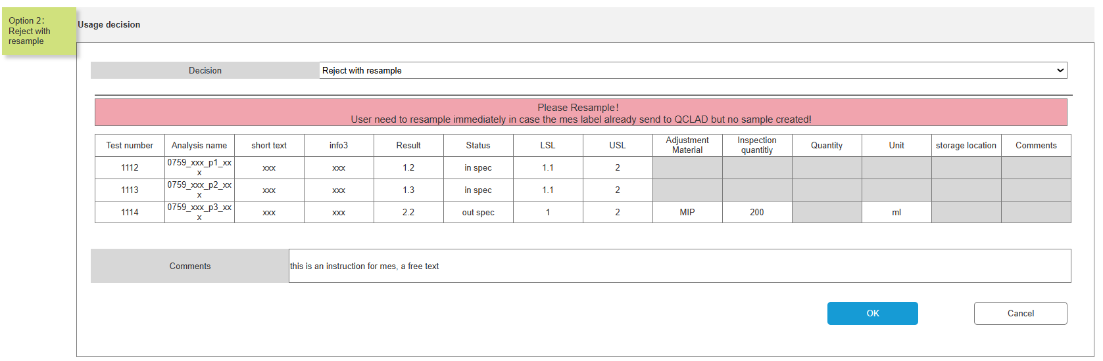
After entering the usage details a pop will be displayed to get confirmation whether to send it to MES or not.
  - If users click “YES” button, the following changes will occur:
    - The “Usage Done” field will be set to YES.
    - The “Hen_to_be_sent” flag will be set to TRUE.
    - The pink highlight will disappear.
  - If users click “No” button, no changes will be made:
    - The fields will remain unchanged.
    - The pink highlight will stay visible.
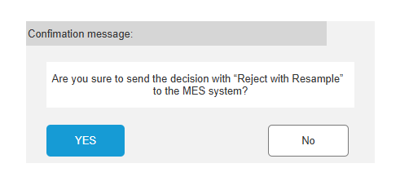
4. Reject with resample
{
"SampleType": "IPQC",
"SampleLabelNumber": "371584",
"ProcessOrder": "001004172754",
"BatchNumber": "0007447212",
"MaterialNumber": "1392015",
"MaterialDescription": "Liquid Detergent Lavender",
"PlantCode": "0799",
"ActivityNumber": "0023",
"AampleApprovalRejectedTime": "YYYY-MM-DD HH:mm:ss", //plant time zone
"OperatorName": "John Doe",
"QCSampleResult": "reject", //Pass or Reject
"IsQCAdjustment": false, [True/False]
"IsFinalRejection": false, [True/False]
"AdjustMaterials": [
{
}
],
"ConsesssionRelease": false, //true or false
"ResampleRequired":true, //true or false
"Remark": "",// commet based on sample level
"QCLabItemResultList":[{
"InspectionLot":"1234567890",
“InspectionCharNumber":"0020",
"MasterInspectionCharacteristics":"00000069",
"InspectionCharacteristicsText":"TENSILE LAP-SHEAR STRENGTH",
"InspectionMethod":"00595101",
"InspectionMethodText":"Shear Strength-Block Specimens",
"LowerSpecLimit":254.5,
"UpperSpecLimit":290.6,
"DecimalPlace":1,
"MeasureUnit":"N/mm2",
"ResultRecordType":"N", //can be N-Numeric or O-Options
"Result":"275.7", //if result is type is N then decimal result as string else pass/fail
"Comments":""
}
]
}

  - Option3: user select “reject with off spec”, Send decision "reject with off spec" without adjustment information.
  - When users select a usage decision and enter all mandatory information, then click the “OK” button, a confirmation popup window will appear.
  - If users click “Cancel” in the popup window, the Usage Decision window will be closed, and no information will be saved.
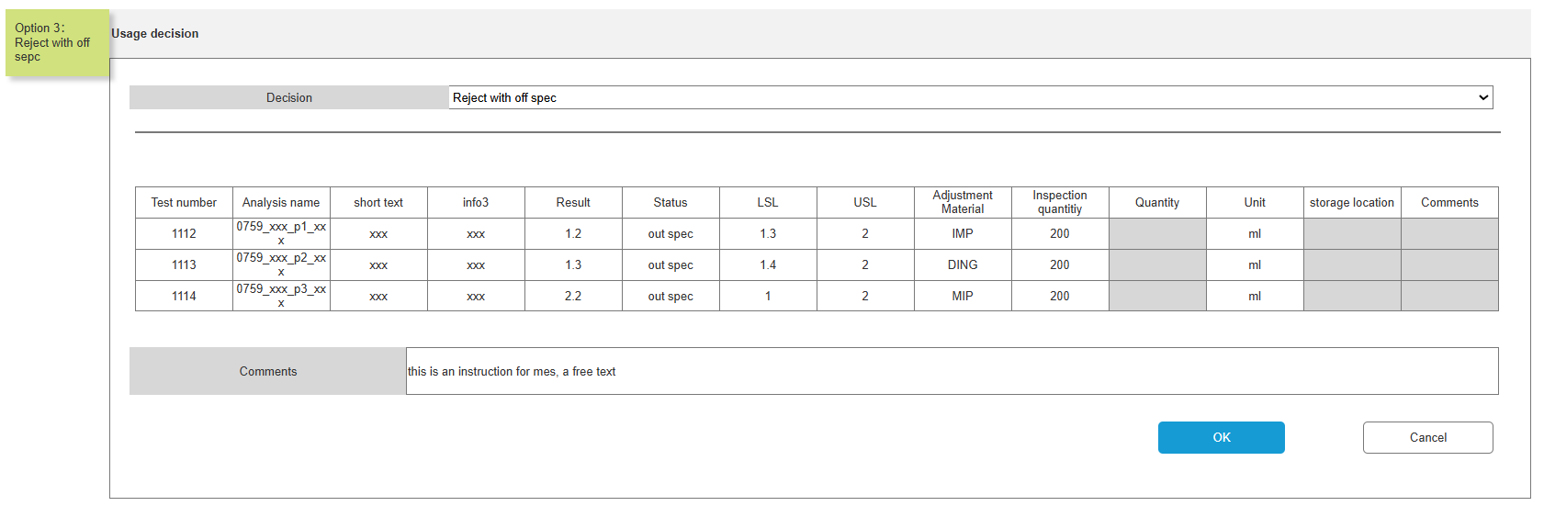
After entering the usage details a pop will be displayed to get confirmation whether to send it to MES or not.
  - If users click “YES” button, the following changes will occur:
    - The “Usage Done” field will be set to YES.
    - The “Hen_to_be_sent” flag will be set to TRUE.
    - The pink highlight will disappear.
  - If users click “No” button, no changes will be made:
    - The fields will remain unchanged.
    - The pink highlight will stay visible.
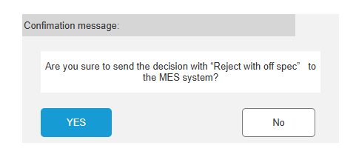

5. Reject with off spec
{
"SampleType": "IPQC",
"SampleLabelNumber": "371584",
"ProcessOrder": "001004172754",
"BatchNumber": "0007447212",
"MaterialNumber": "1392015",
"MaterialDescription": "Liquid Detergent Lavender",
"PlantCode": "0799",
"ActivityNumber": "0023",
"AampleApprovalRejectedTime": "YYYY-MM-DD HH:mm:ss", //plant time zone
"OperatorName": "John Doe",
"QCSampleResult": "reject", //Pass or Reject
"IsQCAdjustment": false, [True/False]
"IsFinalRejection": ture, [True/False]
"AdjustMaterials": [
{
}
],
"ConsesssionRelease":false, //true or false
"ResampleRequired": false, //true or false
"Remark": "",// commet based on sample level
"QCLabItemResultList":[{
"InspectionLot":"1234567890",
“InspectionCharNumber":"0020",
"MasterInspectionCharacteristics":"00000069",
"InspectionCharacteristicsText":"TENSILE LAP-SHEAR STRENGTH",
"InspectionMethod":"00595101",
"InspectionMethodText":"Shear Strength-Block Specimens",
"LowerSpecLimit":254.5,
"UpperSpecLimit":290.6,
"DecimalPlace":1,
"MeasureUnit":"N/mm2",
"ResultRecordType":"N", //can be N-Numeric or O-Options
"Result":"275.7", //if result is type is N then decimal result as string else pass/fail
"Comments":""
}
]
}

  - Option4: user select “Accept with concession”, Send decision "Accept with concession" without adjustment information.

  - When users select a usage decision and enter all mandatory information, then click the “OK” button, a confirmation popup window will appear.
  - If users click “Cancel” in the popup window, the Usage Decision window will be closed, and no information will be saved.
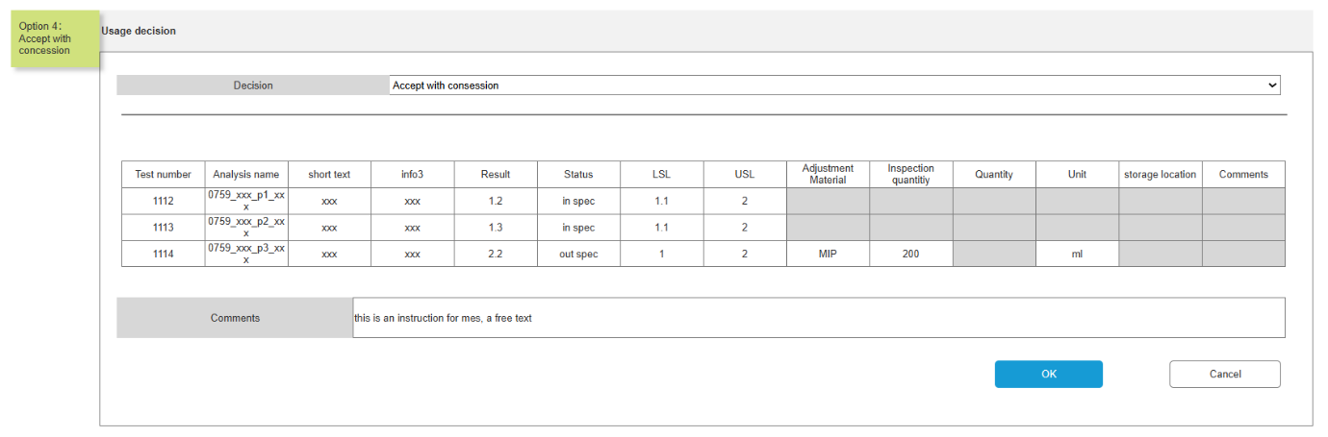
After entering the usage details a pop will be displayed to get confirmation whether to send it to MES or not.
  - If users click “YES” button, the following changes will occur:
    - The “Usage Done” field will be set to YES.
    - The “Hen_to_be_sent” flag will be set to TRUE.
    - The pink highlight will disappear.
  - If users click “No” button, no changes will be made:
    - The fields will remain unchanged.
    - The pink highlight will stay visible.
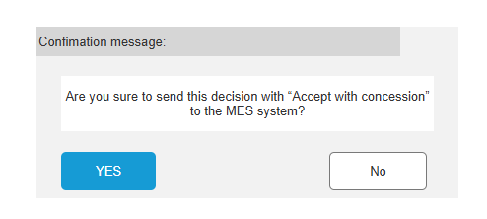
6. Accept with concession
{
"SampleType": "IPQC",
"SampleLabelNumber": "371584",
"ProcessOrder": "001004172754",
"BatchNumber": "0007447212",
"MaterialNumber": "1392015",
"MaterialDescription": "Liquid Detergent Lavender",
"PlantCode": "0799",
"ActivityNumber": "0023",
"AampleApprovalRejectedTime": "YYYY-MM-DD HH:mm:ss", //plant time zone
"OperatorName": "John Doe",
"QCSampleResult": "reject", //Pass or Reject
"IsQCAdjustment": false, [True/False]
"IsFinalRejection": false, [True/False]
"AdjustMaterials": [
{
}
],
"ConsesssionRelease": ture, //true or false
"ResampleRequired": false, //true or false
"Remark": "",// commet based on sample level
"QCLabItemResultList":[{
"InspectionLot":"1234567890",
“InspectionCharNumber":"0020",
"MasterInspectionCharacteristics":"00000069",
"InspectionCharacteristicsText":"TENSILE LAP-SHEAR STRENGTH",
"InspectionMethod":"00595101",
"InspectionMethodText":"Shear Strength-Block Specimens",
"LowerSpecLimit":254.5,
"UpperSpecLimit":290.6,
"DecimalPlace":1,
"MeasureUnit":"N/mm2",
"ResultRecordType":"N", //can be N-Numeric or O-Options
"Result":"275.7", //if result is type is N then decimal result as string else pass/fail
"Comments":""
}
]
}

Usage Completion and JSON Storage
- Trigger Condition: When usage_done = 'Yes' and Hen_to_be_sent = TRUE
- Action: Store adjustment information into a JSON file.
- Implementation Suggestion:
  - Use a scheduled job or trigger to monitor the sample table.
  - Serialize the adjustment data into JSON format.

Add Field for System Destination
- New Field: System_Sent_To (e.g., values: 'MES')
- Purpose: Helps plant team verify where the sample results were sent.
- Implementation Suggestion:
  - Add this column to the sample_table.
  - Populate it during the transmission process.

Transmission Confirmation
- Field: Hen_MES_Has_sent
- Action: Set to TRUE after successful transmission to MES.
- Implementation Suggestion:
  - Update this field in the same transaction that handles the MES push.
  - Include error handling to ensure it's only set on success.

      - Hen_UsageDecisionTask to be written for RMB master menu “Usage Decision Adjustment” and for dropdown select for usage decision, based on the dropdown select value the table values will be loaded.
      - Hen_SendIPQCResultToMESTask to be written to get the user confirmation and send data to MES.

IPQC End-to-End Workflow
QCLADMES
  - Calling Vegam's API using OAuth2 client credentials (Client_Id, Client_Secret)
  - Sending QC sample results in JSON format via POST to Vegam
  - Exposing an API in QCLAD for MES to send IPQC sample info

QCLAD → MES Integration Workflow (IPQC)
Step-by-Step Flow:
1. Sample Created Manually
→ In QCLAD
2. Sample Authorization Done
→ Sample gets approved
3. Checked MICs results are passed or failed
→ QCLAD sends test results to MES using Usage decision and adjustment
3. Get OAuth Token from Vegam
→ Use client ID & secret (shared by Vegam)
→ Call Vegam OAuth API to get Bearer Token
4. Send Sample Result to MES
→ Use Vegam’s API (with Bearer Token)
→ Send sample result JSON (Pass/Reject, QC details)
→ Response will be recorded in the log table
→ Log viewer to review the status of the data transfer

.NET Tasks

Hen_SampleAuthorizeTask
This task needs to be extended as we are adding one additional field “Usage Done” and we need to set value as ‘No’ or ‘Yes’ based on MICs results.

Hen_UsageDecisionTask
When users click on RMB “Usage decision and adjustment” master menu, it will pop-up default windows and will load default values for usage decision task.
And, when users select a usage decision from the dropdown, the values will be loaded based on the dropdown’s selected values.

Hen_SendIPQCResultToMESTask
  - If users click “YES” button, the following changes will occur:
    - The “Usage Done” field will be set to YES.
    - The “Hen_to_be_sent” flag will be set to TRUE.
    - The pink highlight will disappear.
  - If users click “No” button, no changes will be made:
    - The fields will remain unchanged.
    - The pink highlight will stay visible.

Hen_GetOAuthToken()
- Retrieves access token Calling Vegam's API using OAuth2 client credentials (Client_Id, Client_Secret)

Hen_SendSampleResult()
- Sending QC sample results in JSON format via POST to Vegam API

Configuration Specification

Structure Table Updates

New Table: Hen_Adjustment_Table
Field | Is it a primary key | Field type | Mandatory | Description
MLP | Y | Links Mlp_header table | Y
IDH |  | Text |  | sample IDH  Automatically imported from MLP
Analysis | Y | Links versioned_Analysis table | Y
Analysis Name |  | text |  | Automatically imported from Analysis
TestMetthod |  | text |  | Automatically imported from Analysis
Above_standard | Y | Links Phrase | Y | Above standard or below standard  Phrase options ：Above、Below
Adjustment_Material | Y | Links substance table | Y | adjustment IDH
Plant |  | Links hen_Plant table | Y
WorkCenter |  | Links hen_WorkCenter table
storage location |  | Links hen_Plant_location table
Product Line |  | Links hen_Product_line table
modify_on |  | Date |  | Automatically entered by the system
modify_by |  | Links personnel table |  | Automatically entered by the system
Group |  | Links group_header table |  | Automatically import Plant's Group

Example:

Update Table: Sample
Field | Is it a primary key | Field type | Mandatory | Description
Hen_Usage_Done | N | Text (10) | N
Hen_System_Sent_To | N | Text (10) | N

Phrase
Phrase Name | Comments | Action
Hen_Above_Below_Standared | Above standard or below standard | Above  Below

Change Log
Version | Authored by | Change Date | Change Details | Reviewed by | Review Date
1.00 | Madhur Sharma | 17-09-2025 | Initial Version

